BAHRIA UNIVERSITY, ISLAMABAD
Department of Computer Science



INTROUCTION TO DATA SCIENCE LAB

─────────────────────────────

LAB JOURNAL # 04

─────────────────────────────

SUBMITTED BY  Umm-e-Habiba Imran  01-134241-048  6TH A | SUBMITTED TO  Maryam Aslam  Fall 2026  23rd September 2026

Task 1
Write data types of bigsales.csv from above mentioned types
Feature Name | Data type

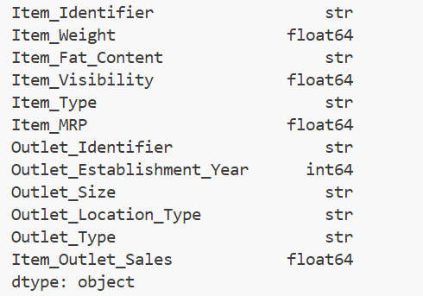

Task 2
How to convert the categorical data into numeric data in python by using Pandas?
# How to convert the categorical data into numeric data in python by using Pandas?
import pandas as pd
data = pd.read_csv('Week4/Train.csv')
data['code'] = pd.factorize(data.Item_Fat_Content)[0]
print(data.head())

from sklearn.preprocessing import LabelEncoder
le = LabelEncoder()
data['code'] = le.fit_transform(data.Item_Fat_Content)
print(data.head())

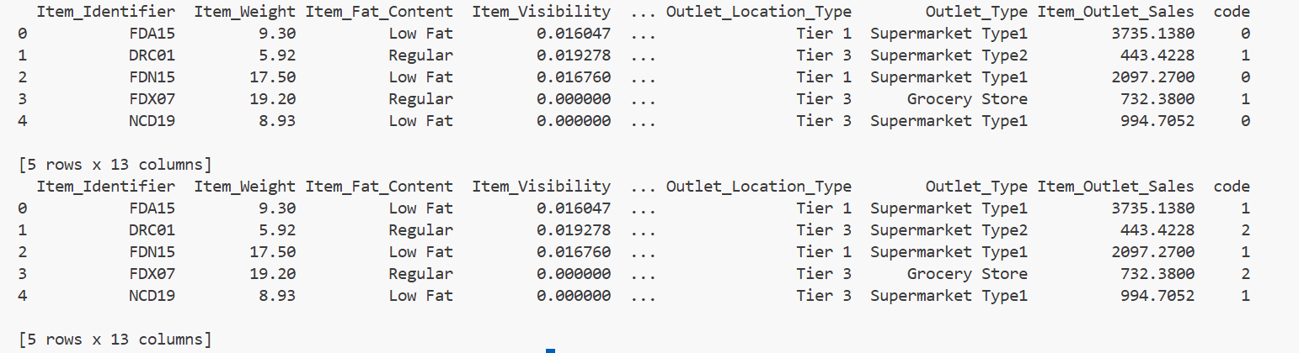

Task 3
The data set is given (download cars/ vehicles dataset), you have to solve the null or missing values by
all the best possible ways. Handle the null values for the particular columns also.

Task 4
Bigmart-sales dataset
Retail is another industry which extensively uses analytics to optimize business processes. Tasks like product placement, inventory management, customized offers, product bundling, etc. are being smartly handled using data science techniques. As the name suggests, this data comprises of transaction records of a sales store. The data has 8523 rows of 12 variables
Import bigmart-sales dataset
- display data
- display datatypes of attributes
- filter by item_type=frozen foods
- append 5 records in existing dataset sort in ascending order and display
- plot boxplot and histogram by outlet_type mention no of bins in histogram
- replace item_weight missing values with “1.00”
- replace outlet_size missing values with “Small”
- drop rows whose outlet_type is missing display no of rows after
- plot boxplot and histogram by outlet_type mention no of bins in histogram compare results after.
import pandas as pd
import matplotlib.pyplot as plt
data = pd.read_csv("Week4/Train.csv")
print("Data:")
print(data.head())
print("\nData Types:")
print(data.dtypes)
frozen = data[data["Item_Type"] == "Frozen Foods"]
print("\nFrozen Foods:")
print(frozen)
new_records = data.head(5)
data = pd.concat([data, new_records], ignore_index=True)

print("\nAfter Appending 5 Records:")
print(data.tail())
data = data.sort_values(by="Item_Identifier")
print("\nData in Ascending Order:")
print(data.head(10))
# ---------------------------------
# BEFORE HANDLING MISSING VALUES
# ---------------------------------

# Boxplot by Outlet_Type
data.boxplot(
column="Item_Outlet_Sales",
by="Outlet_Type"
)

plt.title("Boxplot Before")
plt.suptitle("")
plt.xlabel("Outlet Type")
plt.ylabel("Item Outlet Sales")
plt.xticks(rotation=20)
plt.show()

# Histogram by Outlet_Type
data.hist(
column="Item_Outlet_Sales",
by="Outlet_Type",
bins=10
)

plt.suptitle("Histogram Before")
plt.show()

print("\nNumber of bins = 10")

# Check missing values
print("\nMissing Values Before:")
print(data.isnull().sum())

# Replace Item_Weight missing values with 1.00
data["Item_Weight"] = data["Item_Weight"].fillna(1.00)

# Replace Outlet_Size missing values with Small
data["Outlet_Size"] = data["Outlet_Size"].fillna("Small")

# Drop rows where Outlet_Type is missing
data = data.dropna(subset=["Outlet_Type"])

# Display number of rows after
print("\nNumber of Rows After:")
print(data.shape[0])

# Check missing values after
print("\nMissing Values After:")
print(data.isnull().sum())

# AFTER HANDLING MISSING VALUES

# Boxplot after
data.boxplot(
column="Item_Outlet_Sales",
by="Outlet_Type"
)

plt.title("Boxplot After")
plt.suptitle("")
plt.xlabel("Outlet Type")
plt.ylabel("Item Outlet Sales")
plt.xticks(rotation=20)
plt.show()
# Histogram after
data.hist(
column="Item_Outlet_Sales",
by="Outlet_Type",
bins=10
)
plt.suptitle("Histogram After")
plt.show()
print("\nNumber of bins = 10")

